Day 5: DevOps

## Create GitHub repo:

"**Add** and **commit** all files to the remote repository."

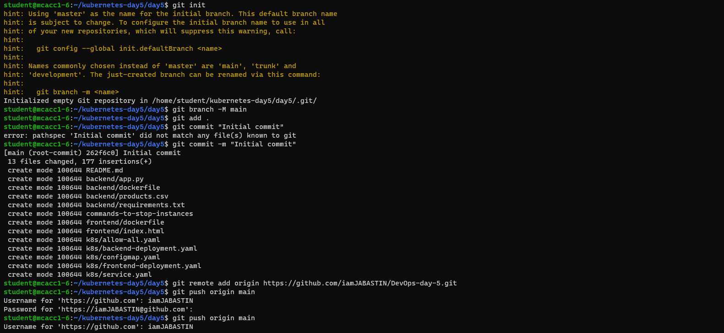

**Push** local changes to the remote repository

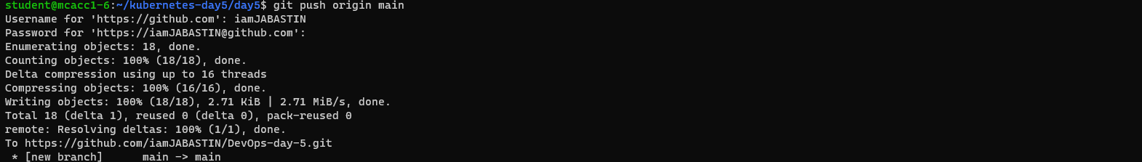

**Create** a Jenkins config file **Jenkinsfile**

A **Jenkinsfile** is a script that defines a **Jenkins pipeline**. It outlines how Jenkins should build, test, and deploy your code. Instead of manually configuring Jenkins jobs through the web interface, you can store the entire pipeline as code in your repository

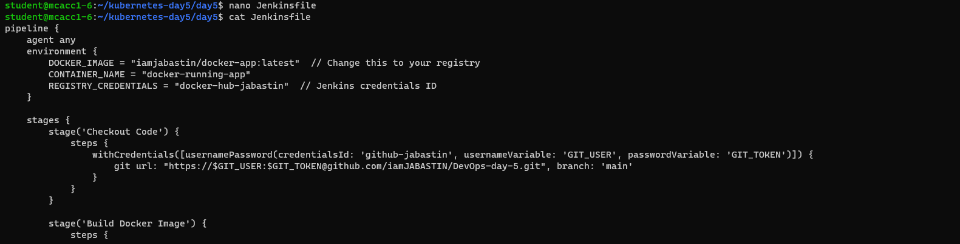

**Enable** and **Start** the Jenkins



Vist the Jenkins in Port 8080

## Jenkins Pipe Line

Create a Jenkins Pipeline

Push the Jenkins file to the Remote Repo

Install **Kubernetes plugin** in Jenkins

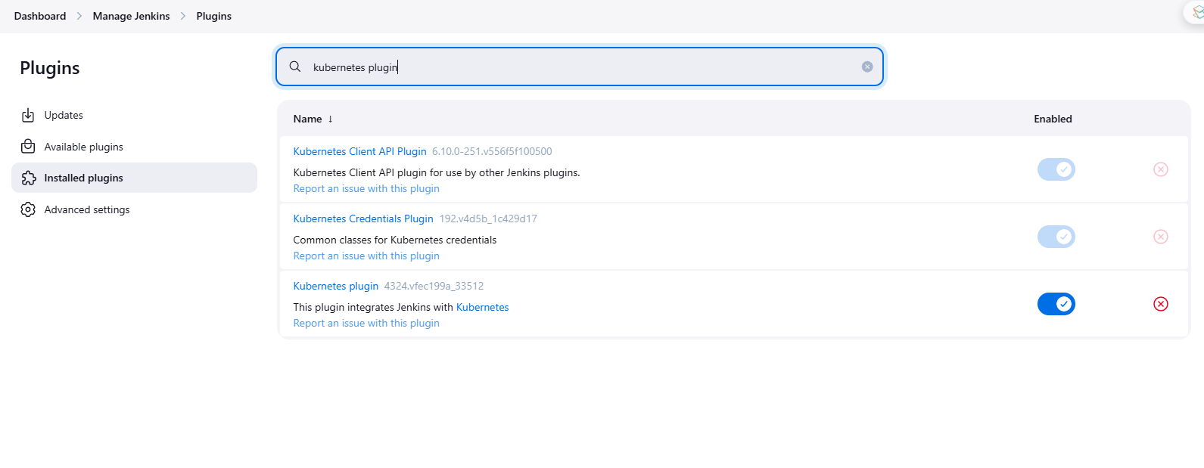

Build the Jenkins

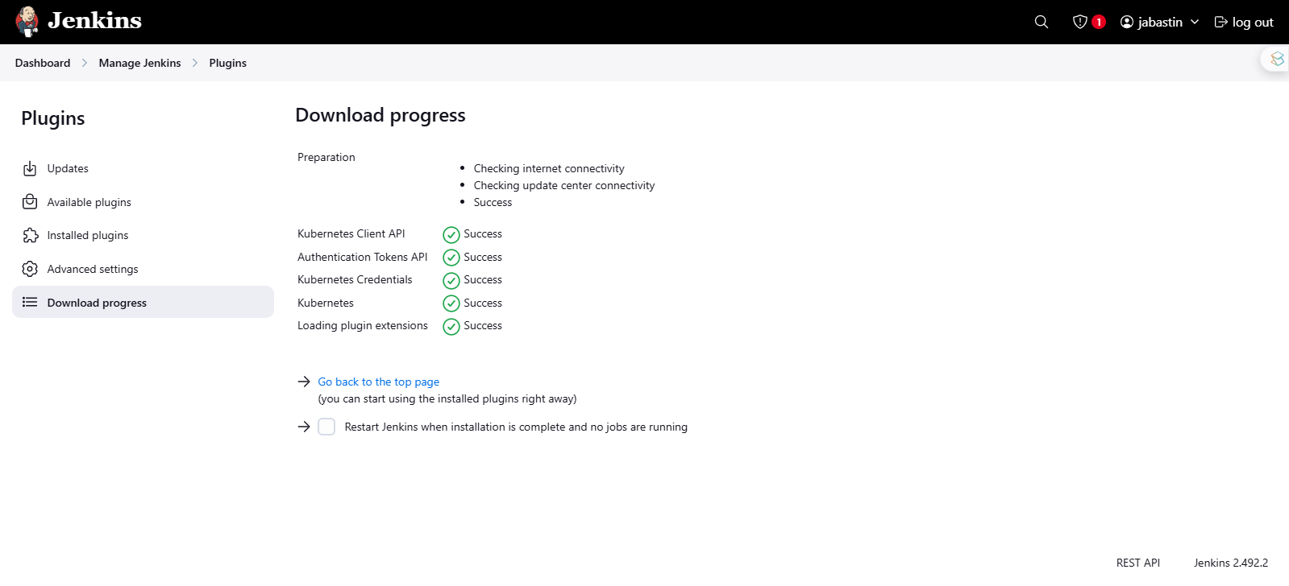

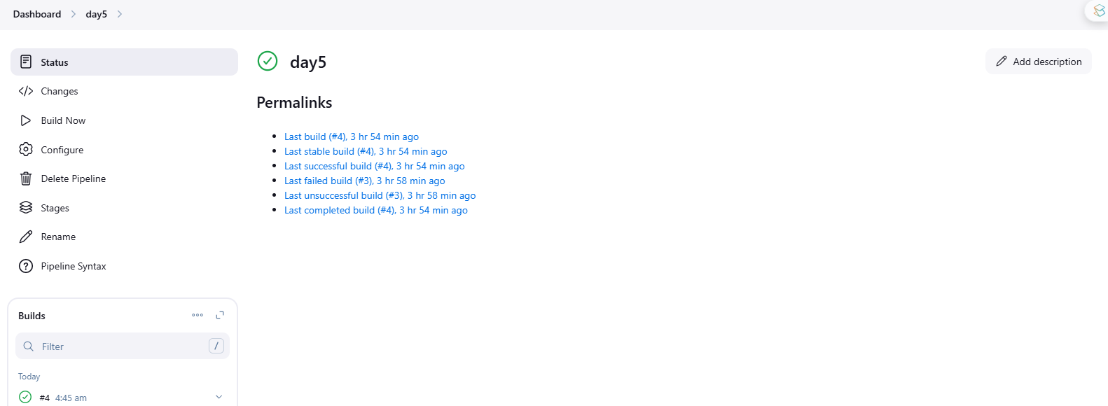

Build successful

**To test Frontend**



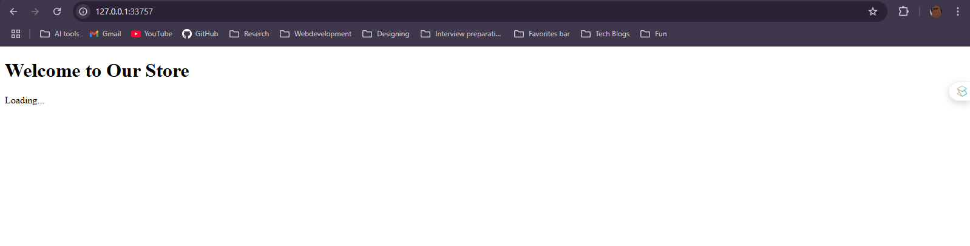

**To Test backend**

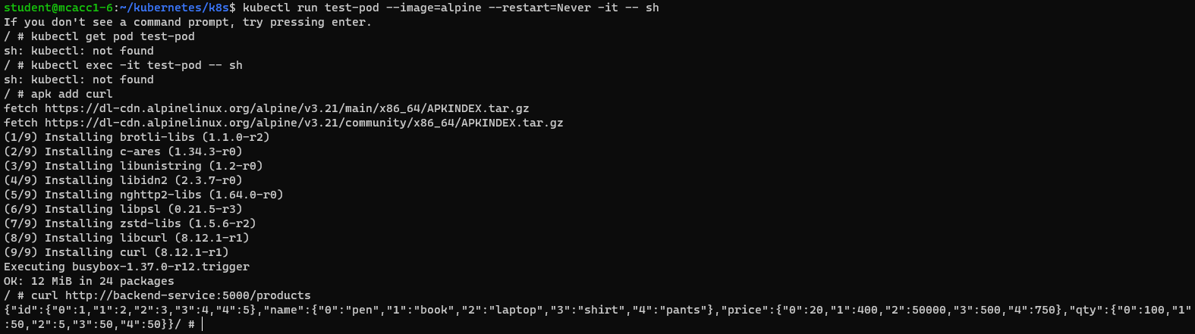

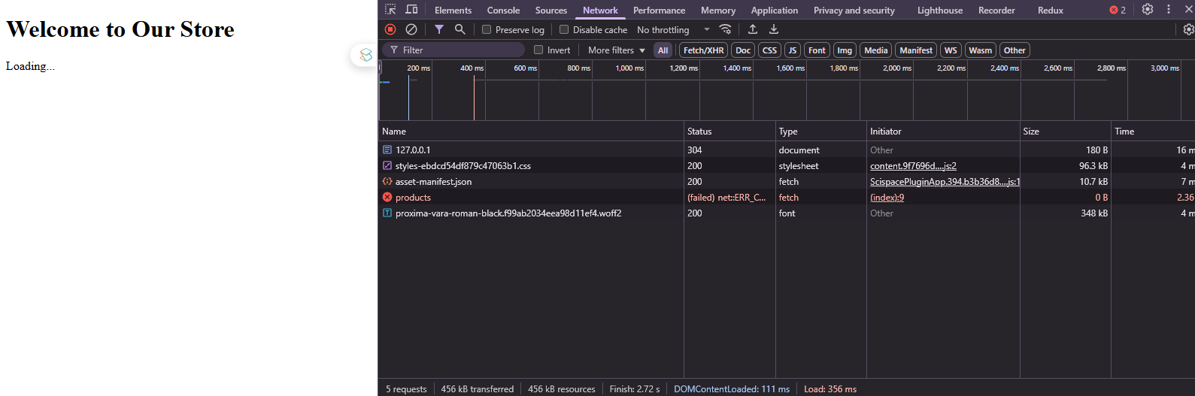

Note: We expect this kind of output because we are running this frontend on localhost.

# — COMPLETED —